Abbreviated CV
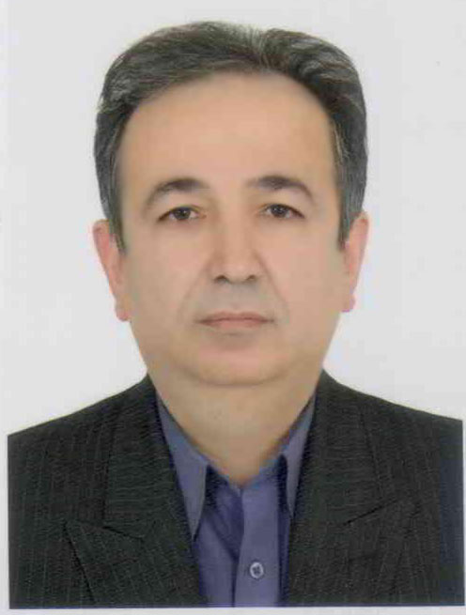

Full name: Seyed Alaeddin Asgari Ghalehbin
Title: Professor of Urology
Address: Work: Urology Research Center, Razi Hospital, Sardar Jangal St., Rasht, Iran
Contacts:
Phone: +98 13 33525259
Email: s_a_asgari@gums.ac.ir

Qualification: M.D.: 1989
National Board of Urology: 1997
Fellowship of Pediatric Urology: 1999

Specialty interest: Reconstructive urological procedures
Work Experiences:
- Head of the Medical Faculty, Guilan University of Medical Sciences, in 2003
- Research Deputy of Medical Faculty, Guilan University of Medical Sciences, in 2000
- Director of the Department of Urology, Guilan University of Medical Sciences since 2008 to 2014
- Member of Urological Evaluation Committee, Ministry of Health and Medical Education, since 2012 to 2014
- Member of kidney transplant team in Razi Hospital, Guilan University of Medical Sciences since 2001 to 2011
- Member of the evaluation committee of faculty members, Guilan University of Medical Sciences since 2000
- The official representative of Urology Journal in Guilan province since 2002

Membership:
- Official member of Société Internationale d'Urologie (SIU)
- Official member of European association of Urology (EAU)
- Official member of Urology Journal Editorial Board
- Founding board member of Guilan Urology Research Center

Spare-time interest: Outdoor sports (mountain climbing) & reading
Sport interests: Football and Martial Arts

Research/papers:
Publication (book):
- Contributed to Text Book of Urology (Iranian Edition) 2006 & 2013
- Male Sexual Dysfunction 2010

Published articles:

- Asgari SA, Mokhtari G, Falahatkar S, Mansour-Ghanaei M, Roshani A, Zare A, Zamani M, Khosropanah I, Salehi M. Diagnostic accuracy of C-Reactive Protein and Erythrocyte Sedimentation rate in patients with acute scrotum. Urol J. 2006 Spring;3(2):104-8.
- Falahatkar S, Mokhtari G, Pourreza F, Asgari SA, Kamran AN. Celecoxib for Treatment of Nocturia Caused by Benign prostatic hyperplasia: A prospective, randomized, double-blind, placebo-controlled study. Urology. 2008 Oct;72(4):813-6.
- Falahatkar S, Salehi M, Asgari SA, Sharifi Hoseini SH, Akbarpour M, Khaledi F, Khaki N, Allahkhah A. Is Ureteral Stenting Necessary After Uncomplicated Ureteroscopy Lithotripsy for Small Middle and Distal Ureteral Stones? UroToday Int J 2009 Oct; 2(5).
- Asgari SA, Falahatkar S, Sharifi Hoseini SH, Enshaei A, Jalili MF, Allahkhah A. Safety and Efficacy of the Herbal Drug Hypericum Perforatum for the Treatment of Premature Ejaculation. UroToday Int J 2010 June; 3(3).
- Mokhtari G, Pourreza F, Asgari SA, Hemmati H, Enshaei A, Emadi SA, Afsharimoghaddam A. En Bloc Bilateral Kidney, Aorta, and Vena Cava Transplantation from a Deceased Pediatric Donor to an Adult Recipient: A Case Report. UroToday Int J 2010 Oct; 3(5).
- Falahatkar S, Asgari SA, Nasseh H, Allahkhah A, Farshami FJ, Shakiba M, Esmaeili S. Kidney Displacement in Complete Supine PCNL Is Lower Than Prone PCNL. Urol Res. 2011 Jun;39(3):159-64.
- Asgari SA, Mohammadi M. The Role of Intraprostatic Inflammation in the Acute Urinary Retention. Int J Prev Med. 2011 Jan;2(1):28-31.
- Asgari SA, Kazemzadeh M, Asl AS, Ghanaei MM. Is Extracorporeal Shockwave Lithotripsy Safe in Patients With Chronic Bleeding Tendency? Urol J. 2011 Fall;8(4):325-7.
- Asgari SA, Mansur Ghanaie M, Falahatkar S, Niroomand H, Iran-Pour E, Safarinejad MR. Pediatric Sutureless Circumcision without Using Skin Closure Adhesives. Urol J. 2012 Winter;9(1):423-8.
- Asgari SA, Asli MM, Madani AH, Maghsoudi PA, Ghanaei MM, Shakiba M, Aval HB, Enshaei A, Farzan A, Esmaeili S. Treatment of loin pain suspected to renal colic with papaverine hydrochloride: A prospective double blind randomized study. BJU Int. 2012 Aug;110(3):449-52.
- Mansour Ghanaie M, Asgari SA, Dadrass N, Allahkhah A, Iran-Pour E, Safarinejad MR. Effects of Varicocele Repair on Spontaneous First Trimester Miscarriage. Urol J. 2012 Spring;9(2):505-13.
- Safarinejad MR, Asgari SA, Farshi A, Iravani S, Khoshdel A, Shekarchi B.Opium consumption is negatively associated with serum prostate-specific antigen (PSA), free PSA, and percentage of free PSA levels. J Addict Med. 2013 Jan-Feb;7(1):58-65.
- Safarinejad MR, Asgari SA, Farshi A, Ghaedi G, Kolahi AA, Iravani S, Khoshdel AR. The effects of opiate consumption on serum reproductive hormone levels, sperm parameters, seminal plasma antioxidant capacity and sperm DNA integrity. Reprod Toxicol. 2013 Apr;36:18-23.
- Asgari SA, Aval HB, Asgari SA, Kheradmand K. A unique case of kidney's collecting system MALT lymphoma. Can Urol Assoc J. 2014 Mar-Apr;8(3-4):E172-5.
- Asgari SA, Safarinejad MR, Poorreza F, Safaei Asl A, Mansour Ghanaie M, Shahab E. The effect of parenteral testosterone administration prior to hypospadias surgery: A prospective, randomized and controlled study. J Pediatr Urol. 2015 Mar 12. pii: S1477-5131(15)00084-4.

